MACH4METAL

metalworking machinery
Transito 21,
6909 DA BABBERICH, Netherlands
Tel. + 31 (0)316 – 247123
Fax. + 31 (0)316 - 247956
info@mach4metal.com
www.mach4metal.com

Bank No : 66.52.13.883
IBAN : NL33 INGB 0665 2138 83
BIC : INGBNL2A

CNC Vertical lathe live tool
SCHERER FEINBAU VDZ 420

- Make : SCHERER Feinbau
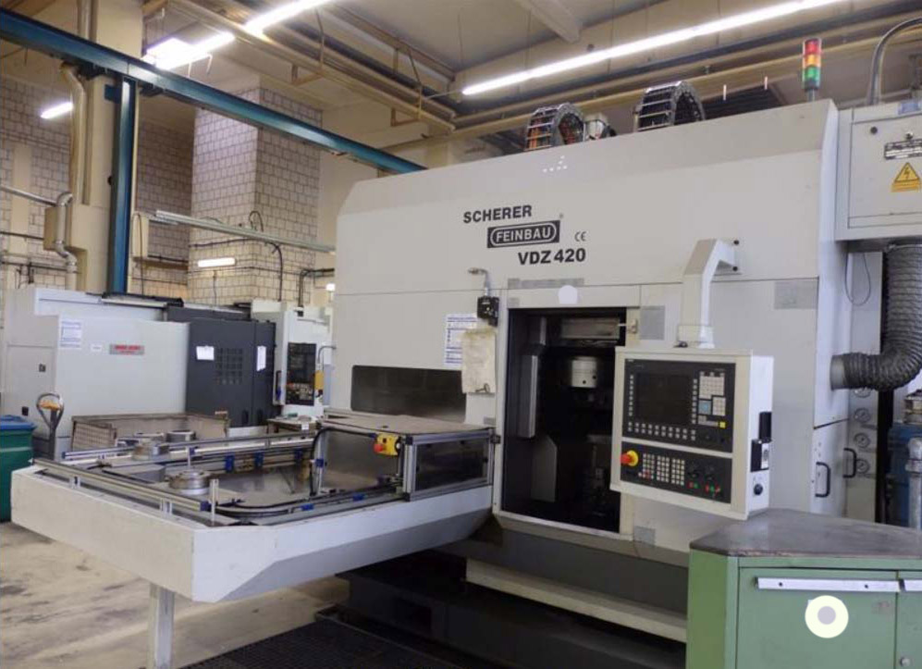
- Typ : VDZ 420
- Age : 2005
- Serial.No : 36005

- Chuck Ø : 550
- Max swing Ø : 550
- Work height : 400

- Speed Rpm : 3.500
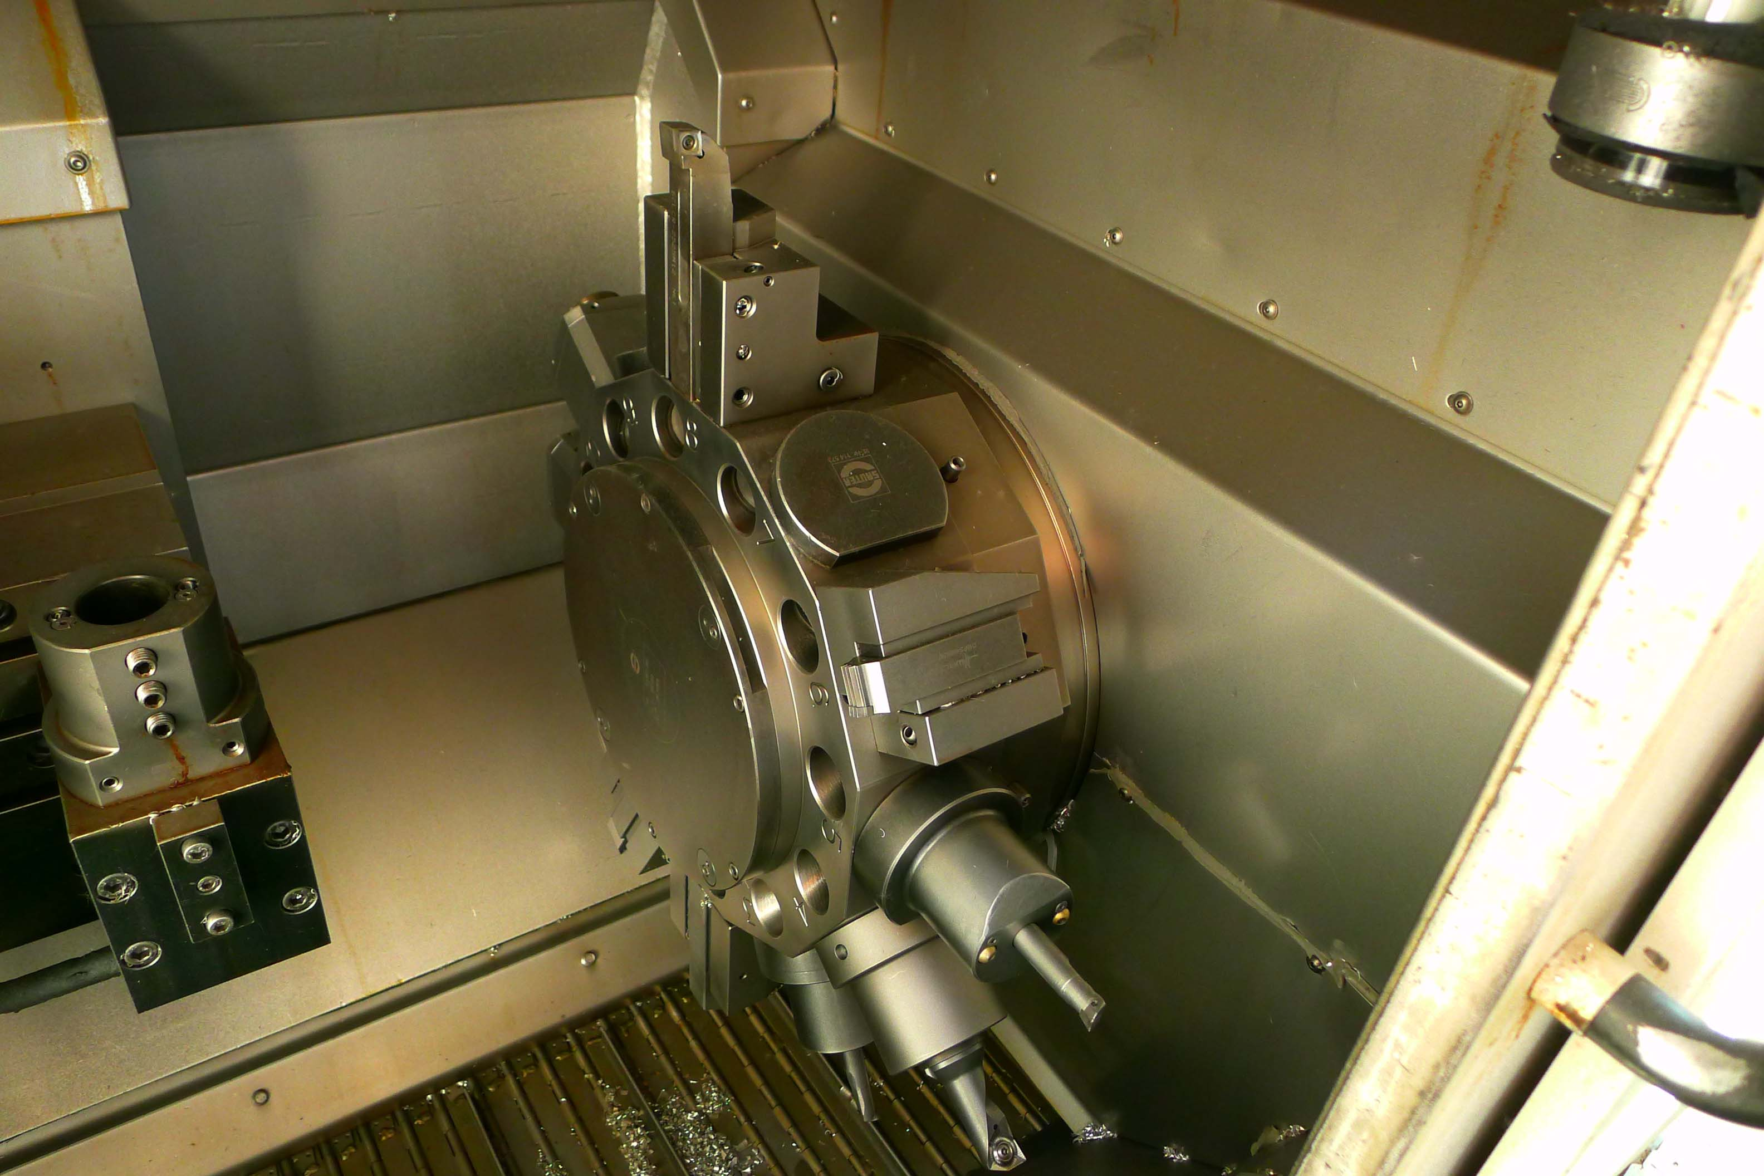
- Spindle hole : 95
- Power on chuck : 60 kW

- Working area
- X travel : 1.785
- Y Travel : 50
- Z Travel : 380

- Tool system : VDi 50
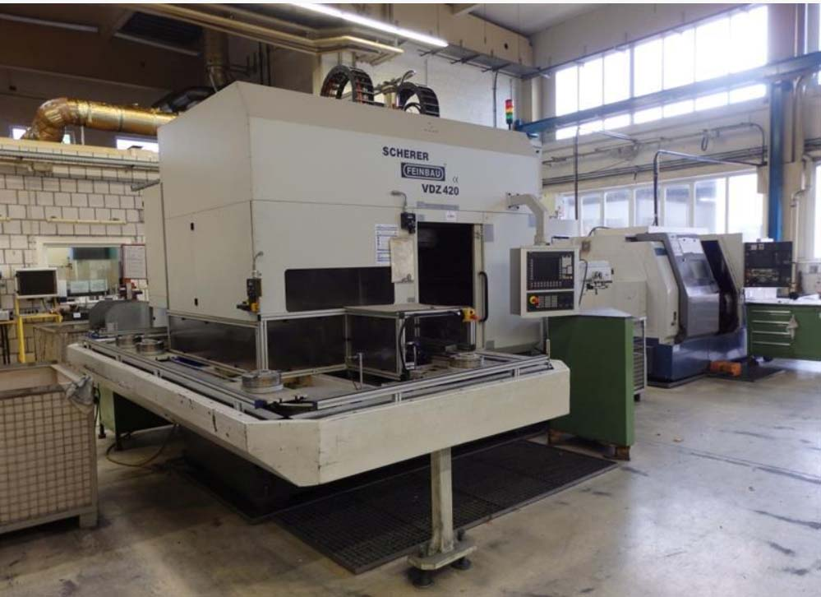
- Sauter turret live tool 12 positions
- Rapid feed : 30.000 mm/M

- Dimensions
- Length : 6.000
- Width : 3.250
- Height : 3.400
- Weight : 14.800

- Siemens 840 D CNC
- High pressure coolant
- Chip conveyor

Please Note: The above information has been obtained to the best of our ability and belief from, and from the manufacturers where possible. It is given in good faith, but its accuracy can not be guaranteed. Accordingly, it will not form a representation or constitute contractual terms. We advise you to check any vital details

